I recommend building it as a web-based Enrollment Analytics and Decision Support System with four major layers:
- Data Collection & Management
- Analytics & Visualization
- AI/Prediction
- Decision Support & Recommendations
Below is a detailed roadmap you can use as your master prompt for developing the system, followed by the system architecture and diagrams.

1. Proposed System
System Title
Visualization of Enrollment Dynamics Utilizing Data Analytics with AI-Driven Decision Support
Main idea
The system will collect historical and current enrollment data and transform it into useful information such as:
- Enrollment trends by year/semester
- Enrollment by program
- Enrollment by year level
- Enrollment by gender, if appropriate and legally/ethically permitted
- Enrollment by department/college
- New vs. returning students
- Retention and dropout patterns
- Student population growth/decline
- Program demand
- Enrollment forecasting
- Identification of unusual enrollment changes
- AI-generated insights
- Recommendations for administrators
The important distinction is that the system should not simply display graphs. It should analyze the data and help administrators answer:
"What happened?" → "Why might it be happening?" → "What is likely to happen next?" → "What should we do?"
2. Master Prompt for Building the System
You can give the following prompt to an AI coding assistant and use it as your overall development specification.

MASTER DEVELOPMENT PROMPT
Project Title
Develop a complete web-based information system entitled:
"Visualization of Enrollment Dynamics Utilizing Data Analytics with AI-Driven Decision Support"
Project Objective
Build a secure, user-friendly, responsive, and data-driven enrollment analytics platform that allows educational administrators to monitor historical and current enrollment patterns, visualize enrollment dynamics, perform statistical and predictive analytics, and receive AI-assisted decision support.
The system must transform raw enrollment records into understandable dashboards, analytical reports, forecasts, alerts, and actionable recommendations.
The system should support the following decision-making cycle:
Data → Information → Analytics → Prediction → AI Insight → Recommendation → Decision

1. SYSTEM USERS
Implement role-based access control.
Administrator
The administrator can:
- Manage users
- Manage roles and permissions
- Import enrollment datasets
- Add/edit/delete enrollment records
- Manage academic years
- Manage semesters
- Manage colleges/departments
- Manage programs
- View all dashboards
- Generate reports
- Run forecasting
- View AI recommendations
- Configure system settings
- View system activity logs
Enrollment Officer / Registrar
The enrollment officer can:
- Upload enrollment datasets
- Validate records
- View enrollment dashboards
- Search/filter enrollment records
- Generate enrollment reports
- View trends
- View forecasts
- Export authorized reports
School Administrator / Decision Maker
The decision maker can:
- View dashboards
- Analyze enrollment trends
- Compare programs
- View forecasts
- Receive AI-generated insights
- View alerts
- Review recommended actions
- Generate management reports
Researcher / Analyst
The analyst can:
- Access approved datasets
- Perform statistical analysis
- Create visualizations
- Compare academic periods
- Generate analytical reports

2. CORE MODULES
Develop the system using the following modules.
Module A — Authentication and Authorization
Implement:
- Login
- Logout
- Password management
- Role-based access control
- Session management
- Account activation/deactivation
- Audit logging
Security requirements:
- Password hashing
- Input validation
- SQL injection protection
- CSRF protection where applicable
- Authentication middleware
- Authorization middleware
- Secure sessions
- Rate limiting for login attempts
- Audit logs

3. DATA MANAGEMENT MODULE
Create a centralized enrollment database.
The system should support:
Academic Information
- Academic year
- Semester
- Term
- College
- Department
- Program
- Major
- Year level
Enrollment Information
- Enrollment count
- New students
- Returning students
- Continuing students
- Transferees
- Graduating students
- Withdrawn students
- Dropped students
- Retained students
Optional demographic variables
Only include demographic fields that are institutionally necessary and permitted by applicable privacy policies.
Examples:
- Sex/gender
- Age group
- Residency category
Avoid collecting unnecessary personally identifiable information.

4. DATABASE DESIGN
Create normalized relational database tables.
Recommended tables:
users
- id
- name
- email
- password_hash
- role_id
- status
- created_at
- updated_at
roles
- id
- role_name
- description
academic_years
- id
- academic_year
- start_date
- end_date
- status
semesters
- id
- semester_name
- academic_year_id
colleges
- id
- college_name
- college_code
departments
- id
- department_name
- department_code
- college_id
programs
- id
- program_name
- program_code
- department_id
- degree_level
- status
enrollment_records
- id
- academic_year_id
- semester_id
- college_id
- department_id
- program_id
- year_level
- enrollment_type
- enrollment_count
- created_at
- updated_at
forecasts
- id
- program_id
- forecast_period
- predicted_enrollment
- lower_bound
- upper_bound
- model_used
- accuracy_metric
- created_at
ai_insights
- id
- insight_type
- title
- description
- severity
- supporting_metric
- recommendation
- created_at
audit_logs
- id
- user_id
- action
- module
- timestamp
- ip_address
- details
Use foreign keys and appropriate indexes.

5. DATA IMPORT MODULE
Allow authorized users to upload:
- CSV
- Excel
- JSON, if required
The import process must contain:
- File upload
- File validation
- Column validation
- Data-type validation
- Missing-value detection
- Duplicate detection
- Invalid-value detection
- Data preview
- Validation report
- User confirmation
- Database insertion
- Import log
Example validation:
If:
academic_year = 2025-2026
program = BSIT
semester = First Semester
year_level = 1
enrollment_count = 180
the system should verify that the record is valid before storing it.
Do not silently accept corrupted data.

6. DATA CLEANING
Implement automated data-quality checks.
Detect:
- Missing values
- Duplicate records
- Negative enrollment counts
- Invalid academic years
- Invalid programs
- Invalid year levels
- Inconsistent naming
- Impossible values
- Duplicate combinations of academic year + semester + program + year level
Display a data-quality score.
Example:
Data Quality Score: 96%
Issues:
- 12 missing values
- 4 duplicate records
- 2 invalid program codes
Allow authorized users to review and correct errors.

7. ANALYTICS ENGINE
Implement descriptive analytics.
Calculate:
Total Enrollment
Total number of enrolled students for the selected period.
Enrollment Growth
Use:
Growth Rate =
(Current Enrollment - Previous Enrollment)
/
Previous Enrollment × 100
Year-over-Year Growth
Compare enrollment between academic years.
Semester Growth
Compare semester-level enrollment.
Program Share
Calculate the percentage contribution of each program to total enrollment.
Retention Rate
Where appropriate:
Retention Rate =
Returning/Continuing Students
/
Eligible Students × 100
Attrition Rate
Where appropriate:
Attrition Rate =
Students Lost
/
Eligible Students × 100
Clearly document the institution's definitions for retention and attrition.

8. DASHBOARD
Create an interactive administrative dashboard.
The dashboard should contain:
KPI Cards
Display:
- Total Enrollment
- Enrollment Growth Rate
- Highest-Enrolled Program
- Lowest-Enrolled Program
- New Students
- Returning Students
- Retention Rate
- Forecasted Next-Period Enrollment
Filters
Provide:
- Academic year
- Semester
- College
- Department
- Program
- Year level
- Student type
Filters must update dashboard visualizations dynamically.

9. VISUALIZATION MODULE
Create professional interactive charts.
Chart 1 — Enrollment Trend
Line chart showing enrollment across academic years/semesters.
Chart 2 — Enrollment by Program
Bar chart ranking programs by enrollment.
Chart 3 — Enrollment by College
Bar chart comparing colleges.
Chart 4 — Program Distribution
Pie/donut chart showing enrollment share.
Chart 5 — Year-Level Distribution
Show enrollment from:
- First Year
- Second Year
- Third Year
- Fourth Year
- Other applicable levels
Chart 6 — New vs Returning Students
Stacked bar chart.
Chart 7 — Retention Trend
Line chart across academic periods.
Chart 8 — Enrollment Heatmap
Show:
Program × Academic Year
using enrollment intensity.
Chart 9 — Forecast
Display:
Historical Enrollment
+
Forecasted Enrollment
Include confidence/prediction intervals where supported.

10. INTERACTIVE VISUALIZATION REQUIREMENTS
Every visualization should support:
- Hover tooltips
- Filtering
- Drill-down
- Date/academic-period selection
- Program selection
- Export
- Responsive design
Clicking a college should allow the user to drill down into its departments.
Clicking a department should allow the user to drill down into its programs.
Example:
College
↓
Department
↓
Program
↓
Year Level
↓
Enrollment Trend

11. AI ANALYTICS MODULE
Implement an AI-assisted analytics layer.
The AI should NOT simply generate generic text.
It should receive verified analytical results from the analytics engine.
For example:
Input:
- Current enrollment = 4,500
- Previous enrollment = 4,850
- Growth = -7.2%
- BSIT growth = +14%
- BSBA growth = -18%
AI output:
"Overall enrollment declined by approximately 7.2%. However, BSIT increased while BSBA declined significantly. Administrators may investigate whether program-specific demand, capacity, scheduling, or recruitment factors contributed to this difference."
The AI should distinguish between:
FACT
Directly supported by data.
TREND
A statistically or visually observable pattern.
FORECAST
A model-generated estimate.
INTERPRETATION
Possible explanation.
RECOMMENDATION
Suggested action.
Never present speculation as fact.

12. AI INSIGHT GENERATION
Generate insights such as:
Trend Insight
"Enrollment has increased for three consecutive academic periods."
Decline Alert
"Enrollment in Program X decreased significantly compared with the previous period."
Growth Opportunity
"Program Y shows sustained enrollment growth and may warrant capacity assessment."
Capacity Alert
"Projected enrollment may exceed the current planning threshold."
Retention Alert
"Retention has declined across multiple periods."
Anomaly Alert
"Enrollment for this program is substantially different from its historical pattern."

13. PREDICTIVE ANALYTICS
Implement enrollment forecasting.
Possible models:
Baseline
- Moving average
- Naive forecast
Statistical models
- Linear regression
- Exponential smoothing
- ARIMA/SARIMA where appropriate
Machine-learning models
If sufficient historical data exists:
- Random Forest
- Gradient Boosting
- XGBoost
- Other appropriate regression models
Do not automatically use complex AI when simpler models perform better.
The system should compare models using appropriate validation metrics.
Possible metrics:
- MAE
- RMSE
- MAPE
Display model performance to administrators.

14. FORECASTING WORKFLOW
Implement:
Historical Data
↓
Data Cleaning
↓
Feature Engineering
↓
Train/Test Split
↓
Model Training
↓
Model Validation
↓
Model Comparison
↓
Best Model Selection
↓
Forecast Generation
↓
Confidence/Prediction Interval
↓
Visualization
↓
AI Interpretation
Forecast:
- Next semester
- Next academic year
- Program-level enrollment
- College-level enrollment
The forecast horizon should be configurable.

15. AI DECISION SUPPORT
Create a Decision Support Center.
For every major insight, display:
Situation
What is happening?
Evidence
What data supports it?
Possible Interpretation
What could explain the pattern?
Forecast
What may happen next?
Recommendation
What action could administrators consider?
Priority
- Low
- Medium
- High
- Critical
Confidence
Display an appropriate confidence indicator based on the underlying analysis/model.
Example:
Situation:
"Enrollment in BSCS has declined for two consecutive semesters."
Evidence:
"Enrollment decreased from 320 to 275 students."
Forecast:
"Model projects approximately 250–265 students next semester."
Recommendation:
"Review recruitment performance, student retention, scheduling constraints, and competitor/program demand indicators before allocating additional recruitment resources."

16. WHAT-IF ANALYSIS
Implement a scenario analysis feature.
Allow administrators to modify assumptions.
Example:
Current enrollment:
5,000
Scenario:
Recruitment improvement:
+10%
Retention improvement:
+5%
Capacity:
5,500
The system calculates an estimated scenario outcome.
Display:
Current Scenario
vs.
Improved Recruitment Scenario
vs.
Improved Retention Scenario
Clearly label scenario outputs as simulations rather than actual predictions.

17. ALERT SYSTEM
Create automated alerts.
Examples:
Enrollment decline
Trigger when enrollment falls below a configurable threshold.
Rapid growth
Trigger when enrollment exceeds a configurable growth threshold.
Retention decline
Trigger when retention falls below target.
Forecast capacity issue
Trigger when forecast exceeds capacity.
Data anomaly
Trigger when an observation is unusually different from historical patterns.
Alerts should contain:
- Alert title
- Date
- Affected program
- Metric
- Current value
- Expected/reference value
- Severity
- Explanation
- Recommended action

18. REPORT GENERATION
Allow administrators to generate reports.
Reports should include:
- Executive summary
- Enrollment overview
- Historical trends
- Program analysis
- College analysis
- Retention analysis
- Forecast
- AI-generated insights
- Recommendations
- Methodology
- Data quality information
Export formats:
- PDF
- Excel
- CSV

19. EXECUTIVE DASHBOARD
Create a simplified dashboard for decision makers.
Show only the most important information:
- Current enrollment
- Enrollment growth
- Retention
- Top programs
- Declining programs
- Forecast
- Alerts
- AI recommendations
Use visual indicators such as:
Green = positive
Yellow = needs attention
Red = critical
Do not use color as the only indicator; include text/icons for accessibility.

20. DATA PRIVACY
The system must protect student information.
Prefer aggregated data for analytics.
Do not expose personally identifiable student information in public dashboards.
Implement:
- Role-based access
- Authentication
- Authorization
- Encryption where appropriate
- Audit logging
- Secure file uploads
- Data minimization
- Access controls
- Backup procedures
AI should receive only the minimum information necessary for the requested analysis.

21. AI SAFETY AND GOVERNANCE
The AI must not make autonomous administrative decisions.
It should provide:
"Decision support"
rather than:
"Automatic decision making."
Every AI recommendation should be reviewable by an authorized administrator.
AI responses should include supporting metrics.
The system should avoid statements such as:
"Program X must be closed."
Instead use:
"Program X shows sustained enrollment decline. Administrators may consider reviewing program demand, retention, recruitment, and resource utilization before making any program-level decision."

22. SYSTEM ARCHITECTURE
Use a modular architecture.
Recommended structure:
Frontend
↓
REST API / Backend
↓
Authentication & Authorization
↓
Analytics Service
↓
AI Decision Support Service
↓
Forecasting Service
↓
Database
Use separate services/modules for:
- Authentication
- Data management
- Analytics
- Visualization
- Forecasting
- AI
- Reports
- Notifications
- Audit logging

23. API DESIGN
Create RESTful endpoints.
Example:
GET /api/enrollment
GET /api/enrollment/trends
GET /api/enrollment/programs
GET /api/enrollment/colleges
GET /api/enrollment/retention
GET /api/analytics/summary
POST /api/data/import
POST /api/forecast
GET /api/forecast
POST /api/ai/analyze
GET /api/ai/insights
GET /api/reports
GET /api/alerts
Use authentication and authorization for protected endpoints.

24. RECOMMENDED FRONTEND PAGES
Create:
1. Login
2. Dashboard
3. Enrollment Overview
4. Enrollment Trends
5. Program Analytics
6. College Analytics
7. Retention Analytics
8. Forecasting
9. AI Decision Support
10. Alerts
11. Data Import
12. Data Quality
13. Reports
14. User Management
15. System Settings
16. Audit Logs

25. UI/UX DESIGN
Use a clean academic/institutional dashboard design.
Recommended layout:
Sidebar:
- Dashboard
- Enrollment
- Analytics
- Programs
- Forecast
- AI Decision Support
- Alerts
- Reports
- Data Management
- Users
- Settings
Top bar:
- Search
- Academic year
- Notifications
- User profile
Main dashboard:
- KPI cards
- Trend charts
- Ranking charts
- Forecast
- AI insights
- Alerts
Design requirements:
- Responsive
- Desktop/tablet/mobile support
- Accessible
- Clear typography
- Consistent colors
- Minimal clutter
- Dark/light mode if appropriate

26. ANALYTICAL QUESTIONS THE SYSTEM MUST ANSWER
The system should allow administrators to answer:
- How many students are enrolled?
- Is enrollment increasing or decreasing?
- Which programs are growing?
- Which programs are declining?
- Which college has the highest enrollment?
- Which programs contribute the most students?
- Which year level has the largest population?
- What is the retention trend?
- What programs show unusual changes?
- What enrollment can we expect next semester?
- What enrollment can we expect next academic year?
- Which programs may require additional capacity?
- Which programs may require recruitment attention?
- What patterns are visible in historical data?
- What possible actions should administrators consider?

27. DEVELOPMENT PHASES
Follow this order.
Phase 1 — Requirements
- Define users
- Define objectives
- Define KPIs
- Define data sources
- Define security requirements
- Define privacy requirements
- Define AI scope
Phase 2 — Database
- Create ERD
- Create tables
- Define relationships
- Create migrations
- Add indexes
- Add constraints
Phase 3 — Backend
- Authentication
- Authorization
- CRUD APIs
- Data import
- Validation
- Analytics APIs
Phase 4 — Frontend
- Login
- Navigation
- Dashboard
- Filters
- Tables
- Charts
Phase 5 — Analytics
- Descriptive statistics
- Growth calculations
- Retention
- Program ranking
- Trend analysis
- Anomaly detection
Phase 6 — Forecasting
- Prepare historical dataset
- Train baseline models
- Train candidate models
- Validate models
- Compare metrics
- Select model
- Generate forecast
Phase 7 — AI
- Build AI insight service
- Pass verified metrics to AI
- Generate explanations
- Generate recommendations
- Add confidence/context
- Prevent unsupported claims
Phase 8 — Decision Support
- Alerts
- Recommendations
- What-if analysis
- Executive dashboard
Phase 9 — Reports
- PDF
- Excel
- CSV
- Executive report
Phase 10 — Testing
Perform:
- Unit testing
- Integration testing
- API testing
- UI testing
- Security testing
- Data validation testing
- Forecast accuracy testing
- AI output evaluation
- User acceptance testing
Phase 11 — Deployment
Prepare:
- Production database
- Backend deployment
- Frontend deployment
- Environment variables
- HTTPS
- Database backups
- Logging
- Monitoring

28. TEST CASES
Create test cases for:
Authentication
- Valid login
- Invalid password
- Disabled account
- Unauthorized page access
Data Import
- Valid CSV
- Invalid CSV
- Missing columns
- Duplicate records
- Negative enrollment
- Empty dataset
Analytics
- Correct total enrollment
- Correct growth rate
- Correct ranking
- Correct retention calculation
Forecasting
- Historical dataset
- Insufficient data
- Missing periods
- Model failure
- Forecast generation
AI
- Correct interpretation
- Unsupported claim detection
- Recommendation generation
- Missing data handling
Security
- Unauthorized API access
- SQL injection
- Invalid file upload
- Session security

29. EXPECTED FINAL OUTPUT
The finished system should provide:
Input
Historical and current enrollment data.
Processing
Data cleaning
+
Statistical analytics
+
Visualization
+
Forecasting
+
AI analysis
Output
Interactive dashboards
+
Enrollment trends
+
Program analysis
+
Forecasts
+
Alerts
+
AI-generated insights
+
Decision recommendations
+
Reports
The final system should demonstrate that data analytics and AI can assist educational administrators in making evidence-based enrollment planning decisions.

30. IMPORTANT DEVELOPMENT RULE
Do not build the entire system at once.
Develop incrementally.
First build:
Database → Authentication → Data Import → Dashboard → Analytics → Forecasting → AI → Decision Support
After every phase:
- Test it.
- Fix errors.
- Document it.
- Commit the working version.
- Continue to the next phase.
Do not implement AI before the underlying data and analytics are reliable.
The AI layer must be based on validated analytical results rather than raw, unverified data.

- Overall System Architecture
- System Flow / Data Flow Diagram
- Use Case Diagram
- Entity Relationship Diagram (ERD)
- AI-Driven Decision Support Workflow
1. Overall System Architecture Diagram
│ Authentication │ Authorization │ Data Management │ API Routing
REST API / BACKEND
Login │ Dashboard │ Enrollment │ Analytics │ Forecast │ AI Support │
│ Reports │ Alerts │ Data Management │ Users │ Settings │ Audit Logs │
WEB-BASED USER INTERFACE
Administrator │ Enrollment Officer │ Decision Maker │ Researcher
SYSTEM USERS

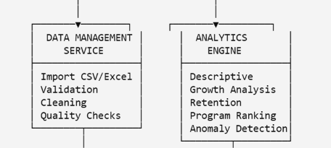

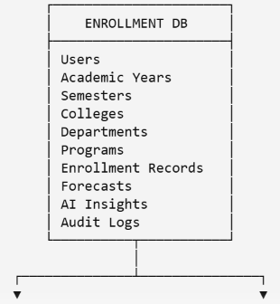

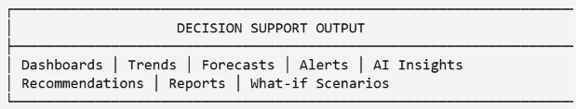
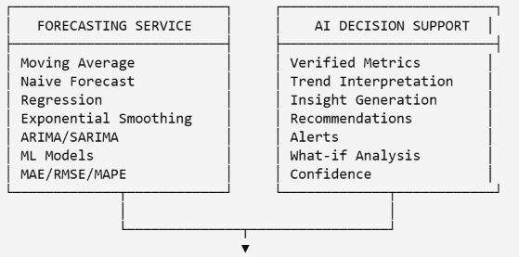

2. Data Flow Diagram — Level 0
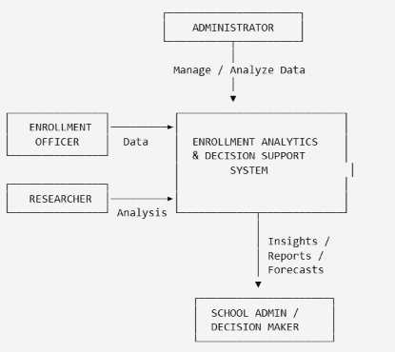
This is suitable as your Context Diagram.

The external entities are:
- Administrator
- Enrollment Officer / Registrar
- School Administrator / Decision Maker
- Researcher / Analyst
The central process is:
Visualization of Enrollment Dynamics Utilizing Data Analytics with AI-Driven Decision Support

3. Data Flow Diagram — Level 1
This gives a more detailed representation of how data moves through the system.
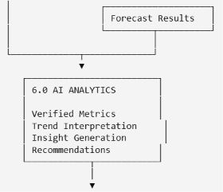
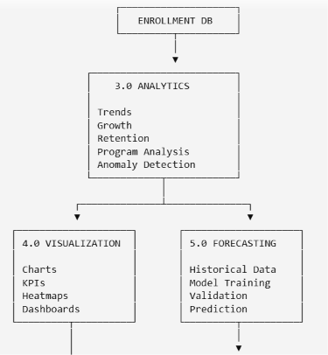
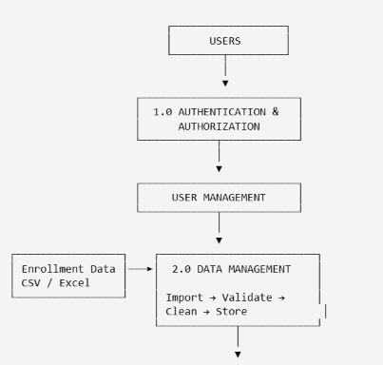

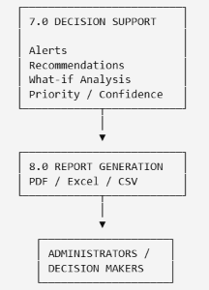

4. AI-Driven Decision Support Workflow
This is probably the most important diagram for your study because it shows how your system goes beyond ordinary visualization.
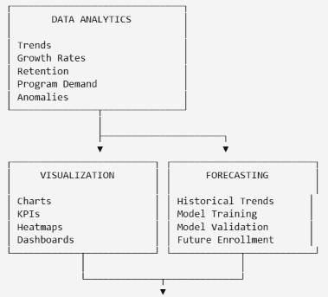
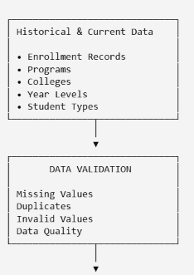

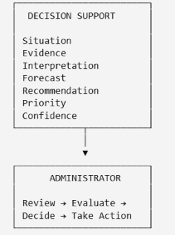
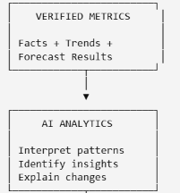

5. Use Case Diagram
You can structure your use-case diagram like this:
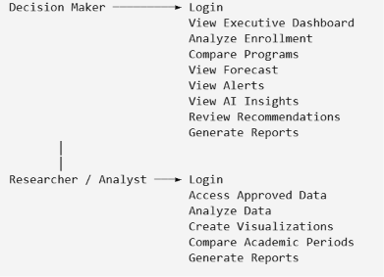
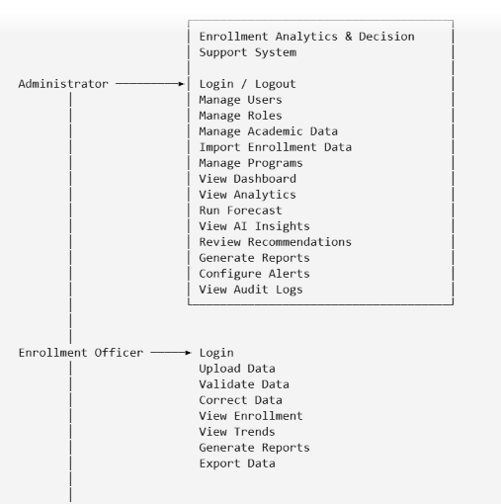

6. Entity Relationship Diagram (ERD)
For your database, I would improve the proposed structure slightly so that the relationships are clearer.
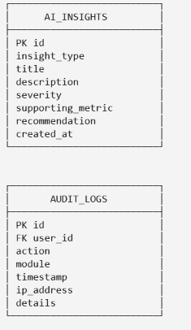
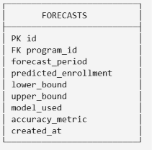
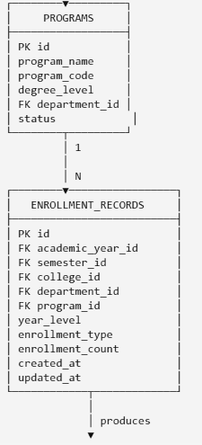
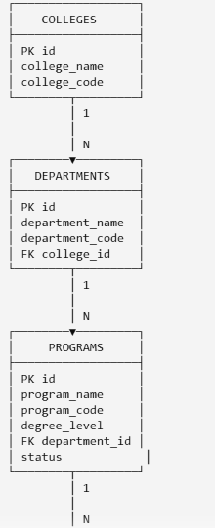
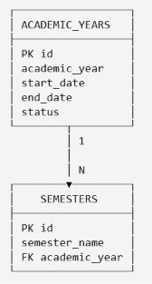
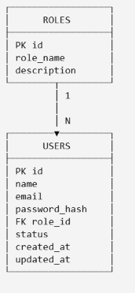

Recommended High-Level Thesis Figure
If you only need one main diagram for your proposal/Chapter 1, I recommend using this simplified conceptual architecture:


